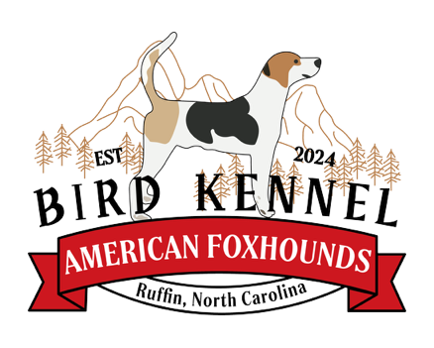

BIRD KENNEL FOXHOUND BUYBACK/SURRENDER AGREEMENT
If at any time, the Buyer can no longer retain possession of the dog, the Seller must be notified. The Buyer must work with the Seller in order to find a new suitable home for the puppy. In the event a new suitable home cannot be found within the Buyers timeframe the puppy would be returned to the Seller so they could find a suitable home. Under no circumstances will the Buyer rehome the dog, which includes surrendering the dog to the pound or any rescue center. This provision is to ensure that our Foxhounds will not end up homeless or destroyed, and a proper suitable home is found. Rehoming of a dog without notifying BIRD KENNEL will be considered breach of contract and the Buyer will be responsible for damages for the actual value of the puppy at the time of original sale (purchase price) and any fees incurred to regain possession of the dog.
Under no circumstances may the Buyer dispatch or euthanize a dog because of poor quality of traits, unwillingness to hunt, or lack of interest in game. The Buyer must notify BIRD KENNEL and discuss surrender of the dog or agree upon a buyback agreement. If the dog does not perform its duties that were intended from the purchase date, BIRD KENNEL will purchase the dog for an amount determined upon once communication is relayed.
Buyer name:
Date:
Foxhound litter enrollment number:
Description of dog:

